**DAILY ONLINE ACTIVITIES SUMMARY**

|  |  |  |  |  |  |  |  |
| --- | --- | --- | --- | --- | --- | --- | --- |
| **Date:** | **18/06/2020** | | | | **Name:** | **Imran Khan** | |
| **Sem & Sec** | **8th A** | | | | **USN:** | **4AL16CS040** | |
| **Online Test Summary** | | | | | | | |
| **Subject** | | **SMS** | | | | | |
| **Max. Marks** | | **60** | | **Score** | | **No mail recieved** | |
| **Certification Course Summary** | | | | | | | |
| **Course** | **Aws** | | | | | | |
| **Certificate Provider** | | | **udemy** | **Duration** | | | **14 HOURS** |
| **Coding Challenges** | | | | | | | |
| Problem Statement:  Write a C Program to generate first N Magic Numbers... | | | | | | | |
| **Status: Solved** | | | | | | | |
| **Uploaded the report in Github** | | | | **yes** | | | |
| **If yes Repository name** | | | | **Imran040** | | | |
| **Uploaded the report in slack** | | | | **yes** | | | |

Online test details:

**Certification Course Details**:

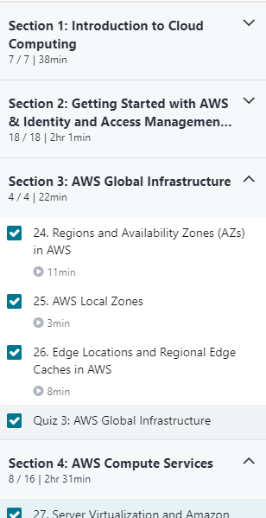

**Coding Challenges Details**:

**program1:**

|  |  |  |  |
| --- | --- | --- | --- |
|  | | | |
|  | |
| #include<stdio.h> | |
|  | |  |
|  | | int nthMagicNo(int n) |
|  | | { |
|  | | int pow = 1, answer = 0; |
|  | | while (n) |
|  | | { |
|  | | pow = pow*5; |
|  | | if (n & 1) |
|  | | answer += pow; |
|  | | n >>= 1; |
|  | | } |
|  | | return answer; |
|  | | } |
|  | |  |
|  | | void main() |
|  | | { |
|  | | int n, i; |
|  | | printf("Enter the value of N: "); |
|  | | scanf("%d", &n); |
|  | | for(i = 1; i <= n; i++) |
|  | | { |
|  | | printf("%d ", nthMagicNo(i)); |
|  | | } |
|  | | } |